Project Report: Conversational IVR Modernization Framework
Topic: Hospital Navigation Assistance IVR
Milestone 1 : Legacy System Analysis and Requirements Gathering

Introduction
Large hospitals are complex environments consisting of multiple departments, wings, diagnostic centers, specialty clinics, emergency units, laboratories, and administrative blocks. Patients and visitors often face difficulty in navigating the premises, leading to confusion, delays, missed appointments, and increased workload for front-desk staff. The traditional help-desk model relies on manual assistance, printed maps, or security personnel to provide directions, which is neither scalable nor efficient during peak hours. The Hospital Navigation Assistance IVR aims to modernize this process by introducing a Conversational AI-based IVR system that provides real-time navigation guidance. The system leverages Twilio-based telephony integration along with Natural Language Understanding (NLU) to guide patients and visitors to specific departments, doctors’ chambers, diagnostic labs, billing counters, pharmacies, and emergency services. This framework transforms a static, manual information model into an intelligent, automated navigation assistant capable of handling high call volumes while improving patient experience.

Problem Statement
Hospitals are high-stress environments where clear communication is vital. Current legacy IVR systems suffer from:
- Navigation Fatigue: Complex "Press 1 for X" menus lead to high call abandonment rates.
- Misrouted Calls: Rigid decision trees often fail to capture the user's true intent, leading to multiple transfers.
- Operational Inefficiency: Staff spend up to 40% of their time answering repetitive "Where is...?" or "How do I...?" questions.
- Lack of Accessibility: Legacy systems rarely support multiple languages or natural speech patterns, alienating diverse patient populations

Objectives
The primary objective of this project is to design and prototype a Conversational Hospital Navigation Assistance IVR that acts as an intelligent guide within hospital premises.
- To automate directional assistance using voice-based interaction.
- To reduce dependency on manual help desks for navigation-related queries.
- To provide real-time, department-specific routing instructions.
- To integrate Natural Language Understanding for identifying location intent.
- To ensure scalable deployment using Twilio telephony integration.

Existing vs Proposed Systems
Feature | Existing System | Proposed Navigation IVR
Input Interface | Manual Inquiry at Help Desk | Natural Voice Interface
Guidance Method | Printed Maps and Verbal Directions | Step-by-Step Automated Voice  instructions
Scalability | Limited by Staff Availability | Highly Scalable using Twilio Infrastructure
Accuracy | Dependent on Human Communication | n Intent-Based Intelligent Routing
Availability | Limited to Working Hours | 24/7 Automated Assistance

5.Architecture and Components
The system follows a 5-layer architecture designed for healthcare-grade reliability and security.
Key Components:
1.Telephony Gateway: Connects traditional phone lines to the digital cloud environment.
2.Cognitive Core:
- ASR (Automatic Speech Recognition): Converts patients voice to text.
- NLU (Natural Language Understanding): Identifies the intent
TTS (Text-to-Speech): Responding in a natural, empathetic human-like voice.
3.Integration Layer: APIs that pull real time data from the hospitals indoor mapping system and HER.
4.Security and Compliance Module: Ensure all the interactions are HIPAA compliant, encrypting PHI (Protected Health Information).
5.Analytics Dashboard: Tracks “Call Containment” rates and identifies common points of confusion in the hospital layout.
5.1 The System Flow Description:
The system flow describes the "journey" of a voice signal from the moment a patient dials the hospital number until they receive navigation guidance.
- Initiation: A user calls the hospital's Twilio-provisioned phone number.
- Voice Capture & Streaming: Twilio Media Streams capture the audio and stream it in real-time to the application backend.
- Speech-to-Text (ASR): The raw audio is processed by an ASR engine into text.
- Intent Analysis (NLU): The text is sent to the AI Engine. The NLU analyzes the request (e.g., "Where is the Radiology department?") to identify the Intent and the Entity.
- Logic & Fulfillment: The Backend retrieves the location data from the Hospital Mapping Database.
- Response Generation: The AI creates a natural response (e.g., "Radiology is on the 2nd floor, turn left past the cafeteria").
- Text-to-Speech (TTS): The text response is converted back into high-quality, empathetic audio.
- Delivery: Twilio plays the audio back to the caller. If directions are complex, the system triggers a Twilio Program
5.2 Sample Conversation Flow:
User: “Where is the Radiology Department?”
IVR: “Radiology is located in 2nd floor. Take the elevator near the main entrance and turn left after the exiting. Would you like directions from a specific entrance?”
User: “Yes, from parking area.”
IVR: “From parking, enter through gate 2 and walk straight to the main lobby.”
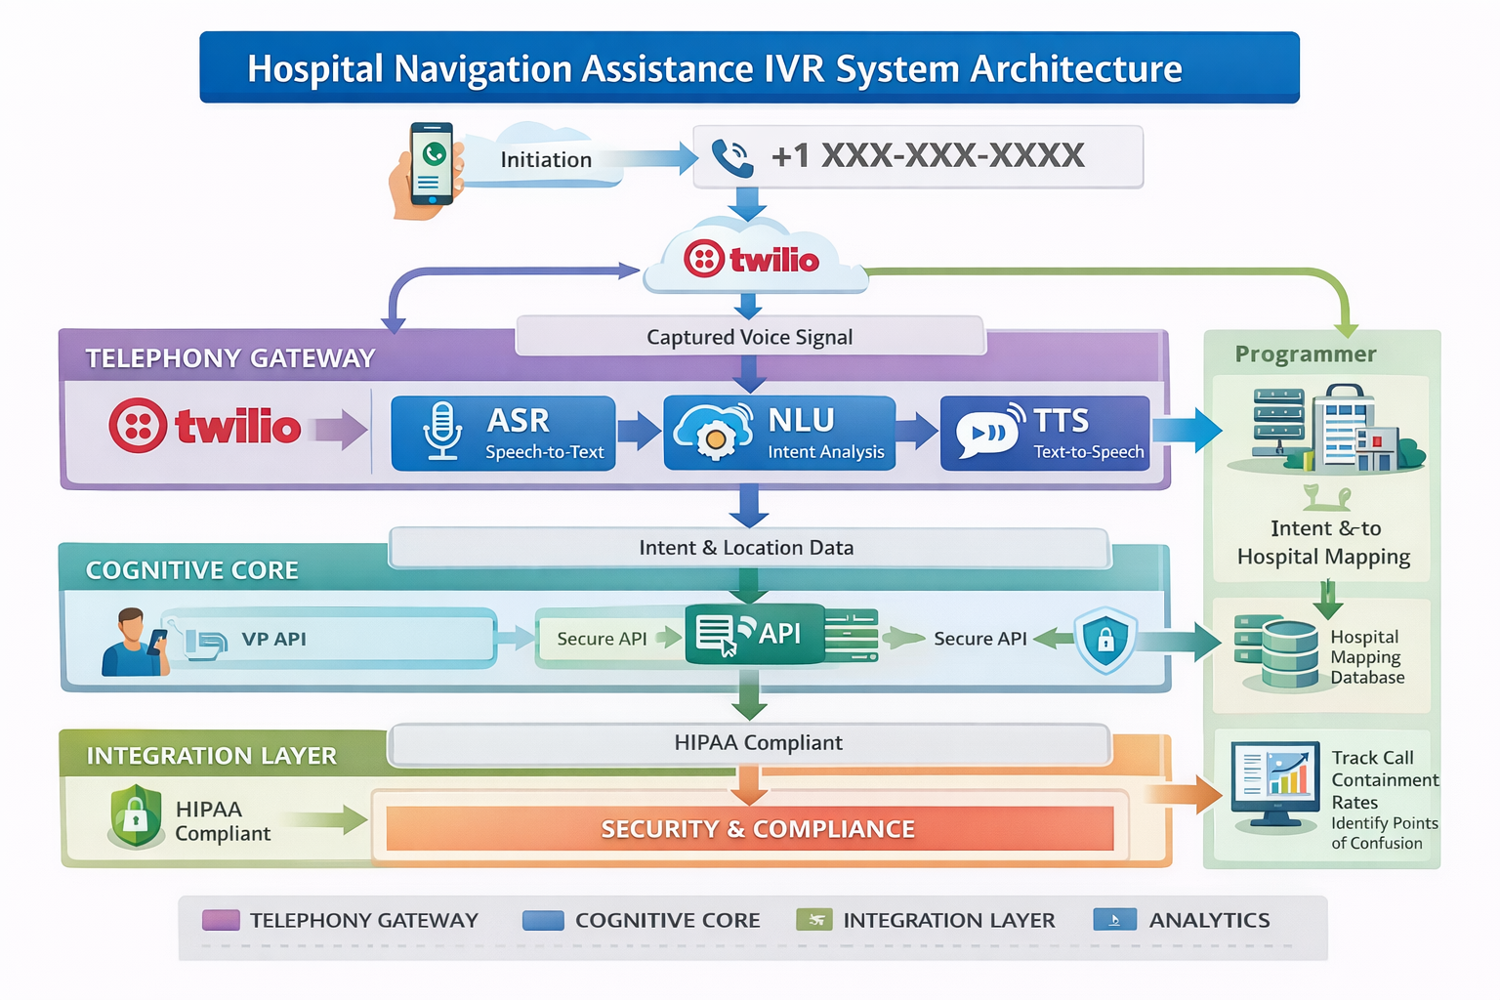

6.Summary
The Hospital Navigation Assistance IVR represents a significant advancement in hospital digital transformation. By automating navigation assistance, the system reduces administrative workload, enhances patient satisfaction, and ensures efficient movement within hospital premises. The framework demonstrates how conversational AI can be leveraged for intelligent facility guidance. This project aligns with modern smart-hospital initiatives and establishes a scalable foundation for future enhancements such as indoor GPS integration, multilingual support, and mobile app connectivity.

